**DESIGN DOCUMENT**

FOR

**IMMERSIVE HUMAN DIGESTIVE TOUR VR APPLICATION**

**Group-12**

Naresh Bharasagar 180101047

Harsh Gupta 180101027

Saurabh Baranwal 180101072

Shivam Agrawal 180101074

Following data flow diagrams represent all the system components as well as the flow of data throughout the system :

**LEVEL 0: CONTEXT DIAGRAM**

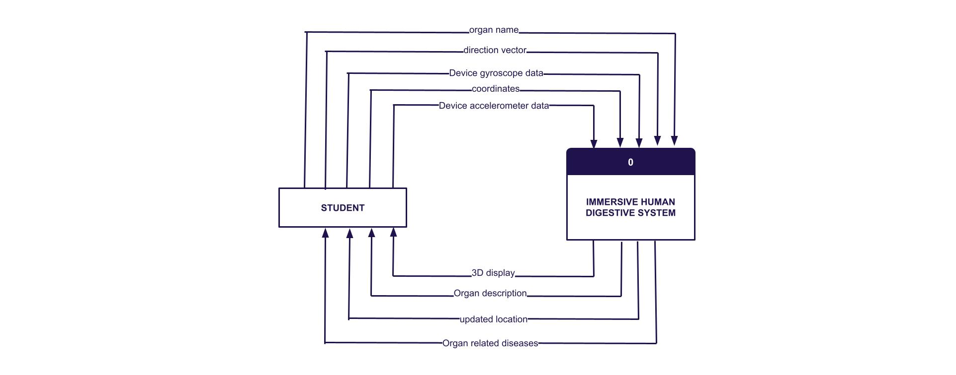

There is only one user i.e. student, and all the inputs coming from the user and outputs coming from the system are shown.

**LEVEL 1: DFD**

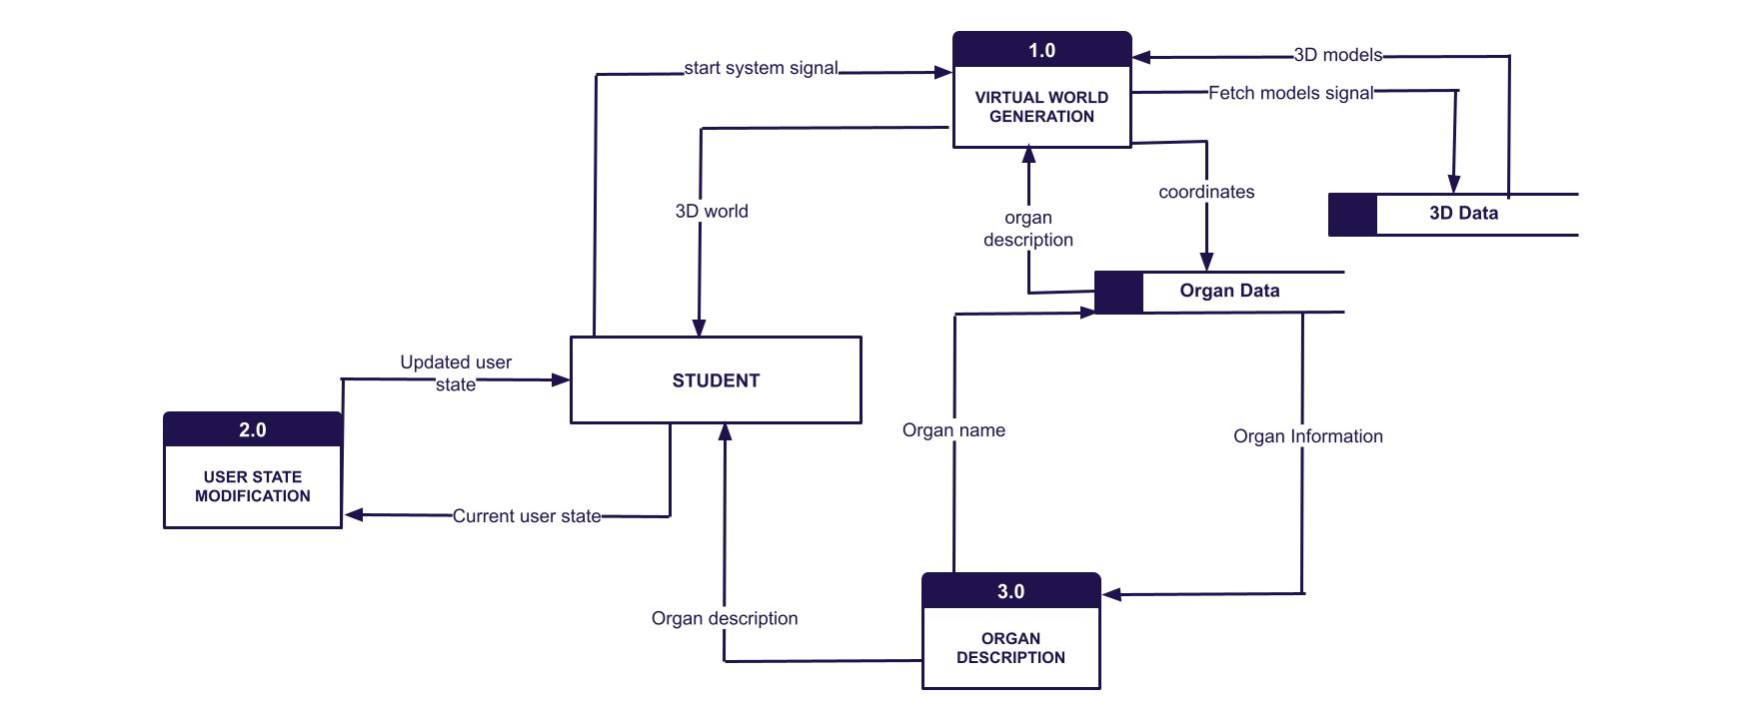

The whole system is divided into three separate modules :

* Virtual World Generation
* User State Modification
* Organ Description

There are two data stores used by these modules :

* 3D data: Containing all the 3D models of organs that are to be placed in the virtual world.
* Organ data: All information related to organs are stored here.

**LEVEL 2: DFD**

Further detailed flow of data within the individual modules is shown here in level two data flow diagrams.

**LEVEL 2.1 -**

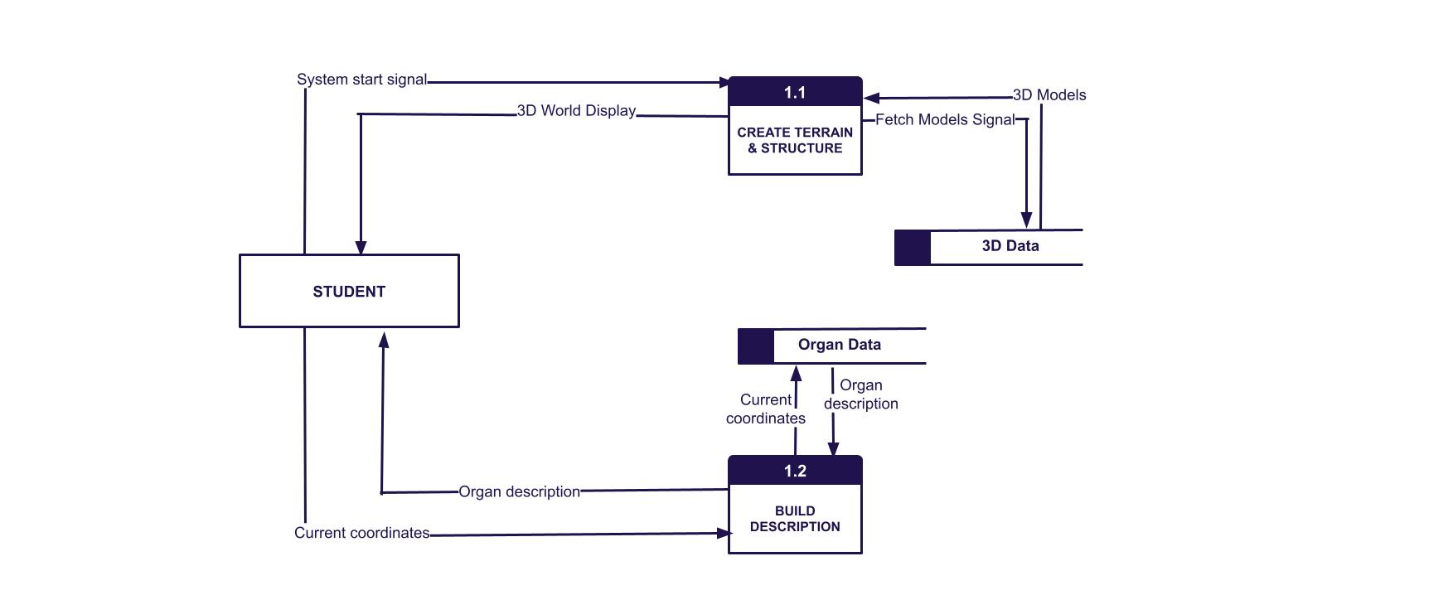

**LEVEL 2.2 -**

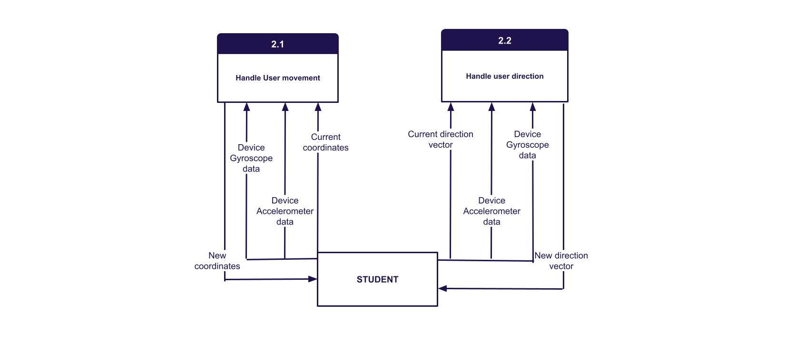

**LEVEL 2.3 -**

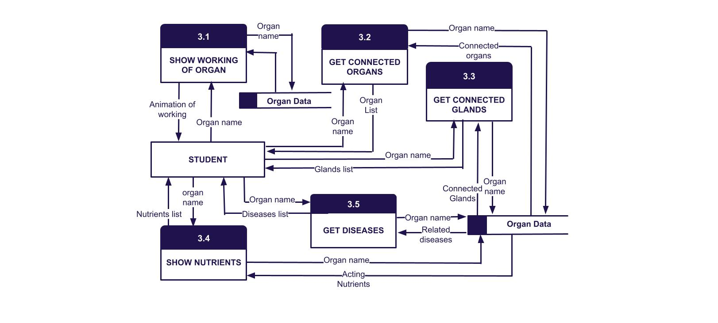

**ER DIAGRAM:**

A compact ER diagram for the two databases used in our system, namely 3D data and organ data, is shown -

